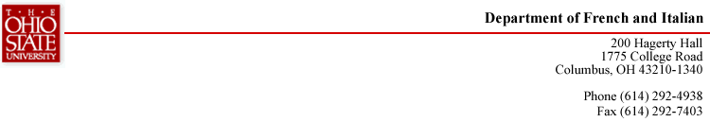

To Whom it May Concern: October 20, 2013

The Italian program in the Department of French and Italian would like to submit the following changes to the Italian Major:

Change:
Italian majors must take It 2102 and at least two 4000-level course on the OSU campus.
To:
Italian Majors must take one 3000-level course or It 2102 and at least two 4000-level or above courses TAUGHT IN ITALIAN on the OSU campus.
Reason:
Students who study abroad often return to OSU with linguistic competency beyond 2102, so we would like the option of awarding credit for 2102 as part of their study abroad equivalency credits.

Change:
Up to 3 credits of 2193 or 5193 and up to 6 credits of 5195 may be counted toward the major provided that they are taught in the Italian language.
To:
Up to 3 credits of 2193 or 5193 and up to 6 credits of 2194 or 5194 may be counted toward the major provided that they are taught in the Italian language.
Reason:
We want to include the lower-level group studies in the limitations on the major. 5493 was originally a typo.

Change:
Up to 3 credits of 4998 (or 4998H) or of 4999 (or 4999H) may be counted toward the major.
To:
Up to 3 credits of 4998 (or 4998H) or up to 9 credits of 4999 (or 4999H) may be counted toward the major.
Reason:
Students need more than 3 credit hours to develop and write an undergraduate thesis.

Change:
Students may count 2 courses taught in the English language (2051, 2052, 2053, 2054, 2055, 5051, and any course at the 7000- and 8000-level) toward the major.
To:
Students may count 1 course taught in the English language…
Reasons:
1) We would like to align with the French program, which only allows one course in English. 2) We would like to increase students’ exposure to Italian. 3) We would like to boost the enrollments in the courses taught in the Italian language.

I have attached the revised description of the major as well as the major form.

Sincerely,

Janice M. Aski
Director of the Italian Language Program

